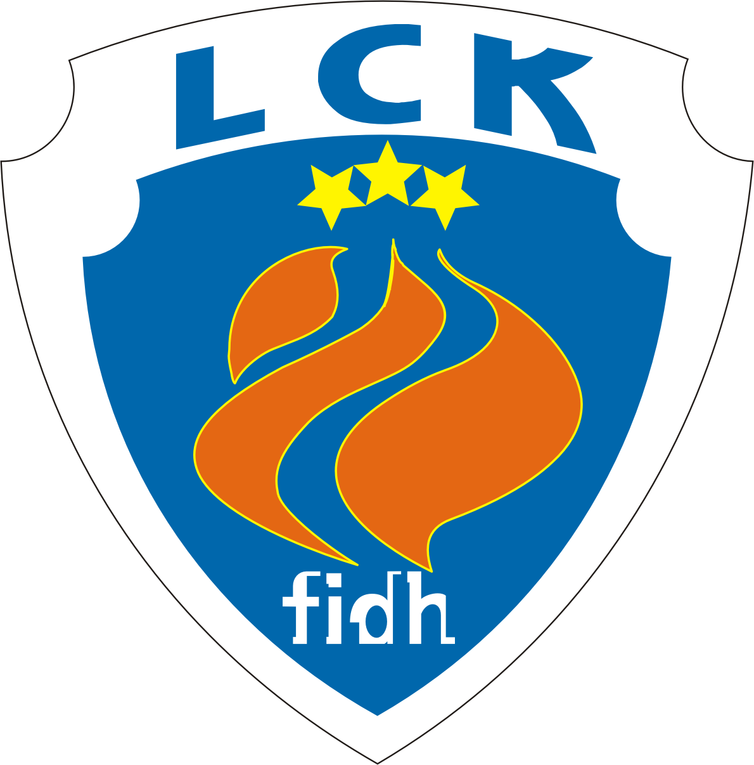
CLSF Latvijas Cilvēktiesību komiteja
F.I.D.H. Latvian Human Rights Committee
МФПЛ Латвийский комитет по правам человека
Reg. No. 40008010632, address: 102a-4, Dzirnavu str. Riga, LV-1050, Latvia. Phone (+371) 26420477 www.lhrc.lv lhrc@lhrc.lv

Riga, 14 February 2014
Human Rights Committee Secretariat
8-14 Avenue de la Paix
CH 1211 Geneva 10
Switzerland
Attention: Kate Fox/Sindu Thodiyil
By post and e-mail

Comments on the List of issues
in relation to the third periodic report of Latvia

[1] Comments on para. 1 (art. 2)
The most notable case concerning direct application of the Covenant has been that of spelling names and surnames of a boy born in Latvia. The embassy of Portugal has issued his birth certificate, with the spellings satisfying the parents. However, the Latvian Office of Citizenship and Migration Affairs (OCMA), recognizing the child to be a Latvian citizen, decided to spell his second name and one part of surname (both ending in a consonant in Portuguese) with the added Latvian ending -s. It has also changed the ending of boy’s first name and second part of the surname (both ending in -o) with an ending –u. After the contestation of that OCMA decision by the parents, on 27 April 2012, the Department of Administrative Cases of the Senate of the Supreme Court submitted the application to the Constitutional Court requesting a review whether the relevant provisions of domestic law are compliant with the Constitution, in the light of the Covenant as interpreted by the Committee in Raihman v. Latvia in 2010.
On 30 May 2012 the Constitutional Court decided not to initiate the proceedings, since in 2001, a similar case was examined and the relevant provisions of domestic law had been declared compliant with the Constitution. The Constitutional Court found no reasons to depart from its findings in that case, claiming that the Views of the Committee aren’t legally binding as such, and are only applicable to a specific case. On 9 July 2012 the Department of Administrative Cases of the Senate of the Supreme Court upheld the judgment of the Regional Administrative Court in favour of OCMA and dismissed the cassation complaint submitted by the parents (case No. SKA-84/2012). The case is pending before the European Court of Human Rights.

[2] Comments on para. 2 (art. 2)
Since the creation of the office, the ombudsmen have submitted 4 complaints to the Constitutional Court. Two of those have resulted in cancelling all or part of contested provisions (cases Nos. 2010-44-01, 2012-15-01), one case was terminated with the court considering that the rights of people concerned are limited with another provision, not the one contested (case No. 2011-12-01), one is pending (No. 2013-15-01). The funding for the Ombudsman’s Office has increased in 2011 and 2012, and is planned to rise in 2014, too. However, even with this rise it is not expected to reach the 2009 level, that before the drastic reduction due to the economic downturn. As at January 2014, the Ombudsman’s Office plans to submit information for accreditation with the International Coordinating Committee of National Institutions for the Promotion and Protection of Human Rights in 2014.
[3] Comments on para. 3 (arts. 2(1), 24 and 26)
Concerning the ethnic composition of the population, it has to be noted that the depopulation is hitting most ethnic minorities harder than ethnic Latvians. Between the censuses of 1989 and 2000, it could be explained mostly by emigration of ethnic Slavs to Russia, Belarus and Ukraine; however, this is not the case for the period between censuses of 2000 and 2011.
The main ethnic groups in Latvia in 2000 and 2011.

Ethnicity | Ethnic population (thousands of people and %) |  |  |  | Decrease of ethnic groups (% by 1989) in period
Ethnicity | 2000 |  | 2011
Ethnicity | absolute group size | % | absolute group size | % | 1989/2000 | 2000/2011 | 1989/2011
All population | 2377.4 | 100 | 2070.4 | 100 | 10.8 | 11.5 | 22.4
Latvians | 1370.7 | 57.7 | 1285.1 | 62,1 | 1.2 | 6.2 | 7.4
Russians | 703.2 | 29.6 | 557.1 | 26,9 | 22.3 | 16.1 | 38.5
Belarusians | 97.2 | 4.1 | 68.2 | 3.3 | 18.8 | 24.2 | 43.0
Ukrainians | 63.6 | 2.7 | 45.8 | 2.2 | 30.9 | 19.4 | 50.3
Polish | 59.5 | 2.5 | 44.8 | 2.2 | 1.5 | 24.4 | 25.9
Lithuanians | 33.4 | 1.4 | 24.5 | 1.2 | 3.5 | 25.8 | 29.3
Jewish | 10.4 | 0.4 | 6.4 | 0.3 | 54.6 | 17.2 | 71.9
Non-Latvians | 1006.7 | 42.3 | 785.2 | 37.9 | 21.3 | 17.3 | 38.6

Not only there are no special measures to remedy that difficult situation – there is no official admission of the issue. Certain comments by a member of the Cenrtral Election Committee nominated by one of co-ruling parties, Mr. R. Eglājs, are especially noteworthy. Analyzing demographical data in his blog, Mr. Eglājs finds that ethnic Latvians have a longer life expectancy than ethnic Russians and birth rate of ethnic Latvians is higher than that of ethnic Russians. His conclusions, highlighted in bold, are as follows: «birth rate is working in favour of ethnic Latvians» and «death rate is working in favour of ethnic Latvians».
The 2013 amendments to the Citizenship Law allow to register a newborn child of non-citizens as a citizens of Latvia upon an application of one of parents (earlier, consent of both parents was needed). This is the only step forward. However, amendments fell short of a default recognition of the newborn children of non-citizens as citizens of Latvia, as advocated by the UN High Commissioner for Refugees, OSCE High Commissioner on National Minorities, Council of Europe’s Commissioner for Human Rights and European Commission against Racism and Intolerance.
Besides, other provisions of the same package of amendments are contrary to the facilitation of naturalization:
- tightening the census of uninterrupted living in Latvia before submitting the application (Section 12 (1)),
- putting vague new criteria for strenghtening the prohibitions to naturalize and entrusting evaluation of some of them to executive instead of court (Section 11),
- prescribing that a refusal by the Cabinet of Ministers or by the Prosecutor-General cannot be appealed against (Section 17(4) and Section 17(5)).
As a result, no acceleration of naturalization rates (which was fluctuating between 2000 and 2500 persons a year in 2009-2012 and fell to 1732 in 2013 – less than 10 % of the top number achieved in 2005) is expected. Notably, the naturalization in Latvia is not the cause of most reduction in the number of non-citizens anymore, - death rate and obtaining citizenship of other countries are more significant. E.g., in 2012, when 2213 persons were naturalized, the number of non-citizens has fallen by 14,306. The number of Latvian non-citizens residing abroad in the second half of that year has grown by only 232 (data for the first half of 2012 aren’t available).
Besides, the expanded possibilities of dual citizenship (Section 9) are now questionable with regard to both selective approach to the choice of the states it can exist with, as a general rule (including not only EU, EFTA and NATO partners, but also Australia, Brazil and New Zealand, while excluding Russia and Belarus – neighbouring countries and countries of origin for most of ethnic non-Latvians living in the country) and preferences given to ethnic Latvians and Livs.
The requirement to communicate in Latvian with public institution and authorities remains both a sign of unwillingness to recognize diversity of Latvian society and a practical problem for the prisoners, elderly people and in the areas next to the Russian and Belarusian borders, where Latvian language environment is limited. Notably, Latvia has made a restrictive declaration on the use of minority languages while ratifying the Framework Convention for the Protection of National Minorities in 2005. Still, the situation with the use of minority languages was harshly criticized by the Committee of Ministers of the Council of Europe.
The Latvian language proficiency requirements in employment, defined by the government, became applicable to more than 1000 professions in private sphere (initially, in 2000, there were 34 such professions listed in Annex 2 to the Cabinet regulations No 296 of 22.08.2000) and virtually all professions in public sphere. Cases of obvious disproportionality include equal Latvian language requirements for all public school and nursery teachers, irrespective of the language of instruction. Fines for insufficient command of Latvian language for professional purposes were raised substantially in 2011, with the fines for repeated violations now reaching up to EUR 700. In 2013, the cases of fining people for insufficient command of Latvian formed 52 % of the 1157 fines imposed by the State Language Centre.
In June 2012, a prohibition for employers to include in the workplace announcements requirements for specific „foreign language” skills not necessary for the job was included in Section 32 of the Labour Law. While the text itself could be understood as reasonable (although it lacks recognition, that disproportionate requirements for Latvian language skills can be discriminatory, too), according to the annotation of the draft law, it is planned to apply the provision against interests of numerous Russian-speaking customers, whose preferences are considered to be insufficient for requring employees to have Russian language skills.
Finally, one cannot evade the aftermath of the only Latvian case when the Grand Chamber of the European Court of Human Rights found discrimination to happen – 2009 judgment in Andrejeva v. Latvia (application 55707/00). The essence of the violation was the impossibility for the “non-citizens” to benefit from state pension rights acquired before 1991 when working in other republics of the former USSR.
While Ms Andrejeva was paid just satisfaction, other “non-citizens” either receive pensions for the relevant time only after Latvia concludes a social security agreement with a relevant post-Soviet state, without any compensation for the preceding discrimination, or do not get the relevant time taken into account for calculating pensions at all, in the absence of such agreements. This policy was declared compliant with the Constitution and the European Convention on Human Rights by the Constitutional Court in February 2011. The European Commission against Racism and Intolerance noted in 2011 that “the Constitutional Court’s decision, at best, gives a very narrow interpretation of the ECtHR’s judgement”. The Ombudsman, however, considers that “The former citizens of USSR without the citizenship of the Republic of Latvia or any other country [an alternative name of the so-called “non-citizens”, with both terms appearing in laws – note by LHRC] enjoy social guarantees equal to those available to the citizens of the Republic of Latvia”, as at 2013.
This is not the first statement of the kind by the current Ombudsman Mr. J. Jansons – in 2011, he declared that “The principle of equality allows and even requires different attitude to people in differing circumstances. Thus, a difference between the volume of rights of non-citizens and citizens cannot be considered discriminatory”. It should be noted that his predecessor, Mr. R. Apsitis, has found seven differences between the rights of citizens and non-citizens in the fields of owning real estate and employment to be disproportionate in 2008 (one of those – the prohibition for non-citizens to work as heads of detectives’ bureaus – was cancelled later).
[4] Comments on paragraph 6 (arts. 2(1, 3, 26))
No specific legislative provisions are introduced to combat hate crime against lesbian, gay, bisexual and transgender persons.
[5] Comments on paragraph 9 (art. 2(1), 3, 26)
The Criminal Law does not contain separate provisions criminalizing domestic violence and spousal rape.
[6] Comments on paragraph 13 (arts. 2, 7, 9, 13).
We consider that the Internal Security Office of the State Police is not an independent mechanism to investigate complaints of unlawful conduct against members of the police, in the view of para. 23. of the UN Basic Principles on the Use of Force and Firearms by Law Enforcement Officials, as well as para. 2 of the Principles on the Effective Investigation and Documentation of Torture and Other Cruel, Inhuman or Degrading Treatment or Punishment (GA resolution 55/89) and para. k) of the General Recommendations of the Special Rapporteur on Torture (E/CN.4/2003/68).
In connection with this issue, there was a complaint No. 85/2011 raised before the Constitutional Court with our assistance; however, the Court declined to initiate a case on the complaint, by a decision of 22 June, 2011. In its reasoning, the Court stressed the fact that the Prosecutor’s Office, to which complaints are possible, is a part of judiciary. Notably, the same is the case in Russia in accordance with Chapter 7 of its Constitution, but this did not prevent the European Court of Human Rights from finding a violation in an analogous case Belevitsky v. Russia (judgment of 01.03.2007 on application No. 72967/01). The case is now pending before the European Court of Human Rights as the application No. 1764/12.
[7] Comments on paragraph 17 (art. 9, 10)
Reducing the incarceration rate (from 353 per 10,000 in 2004 to 304 in 2013) has had a positive impact to the guaranteeing a living space per prisoner. Notably, a package of amendments to the Criminal Law having entered into force in 2013 also reduces the use of deprivation of liberty – it is expected that the average term of deprivation of liberty will drop from 6 years to 4 years.
In February 2013, the Cabinet of Ministers has adopted the Concept for Prison Infrastructure Development, including the plan to build a new big prison in Olaine town in 2016-2017. However, as at November 2013, there were still doubts over whether the construction will be moved elsewhere.
[8] Comments on paragraph 19 (art. 14)
Non-citizens and stateless persons can benefit from the state-guaranteed legal aid on equal footing with the citizens. With the foreigners, the situation is more complicated. By law, access to the state-paid legal aid (outside of the general right to defence in criminal cases) is granted only to:
1) Citizens of EU member states, legally residing in Latvia,
2) Foreigners with a permanent residence permit,
3) Asylum seekers.
The other people, including those having a temporary residence permit, can benefit from state-paid legal aid only in exceptional cases – i.e., deportation cases and (for those having a domicile in the EU) cases of international character.
[9] Comments on paragraph 20 (art. 19)
The access to information for non-Latvian speakers is, in practice, limited by the language policy despite the fact that the problem is mitigated by improving Latvian skills. Even private persons are sometimes under risk of fines for having, e.g., bilingual plates on their houses, but mostly, the information provided by public bodies is affected.
Notably, the State Language Centre (under the Ministry of Justice) is resisting attempts by state or municipal bodies to provide information in non-official languages outside of the few cases where it is allowed. The publicly-known record of the centre includes warning to a Russian minority municipal school for the fact that city mayor spoke with its pupils in Russian at the beginning of the academic year, as well as prohibiting the following information in non-official languages (usually Russian, but also English), from being put in public places or sent to people without a prior request:
- police booklets for residents,
- bilingual anti-corruption posters intended for hospitals,
- information in railway stations not involved in international carriages,
- reading aloud the names of stops in trams of mostly Russian-speaking Daugavpils city,
- booklets about transition to euro,
- and, finally, invitations to women to undergo oncological checks (!).
The Ombudsman was invited to express his opinion on the latter case in 2013, and he did not find any human rights violations.
A notable fact in this regard is the possibility (in force since January 2009) of fines for providing information in a „foreign” language along Latvian in cases when the use of Latvian only is prescribed – a purely „victimless offence” of nothing but being „too respectful” for minorities. It is punished by fines up to EUR 140 (Part 7 of Section 201.³⁵ of the Administrative Violations Code). As at the end of 2012, the provision was used 10 times as a reason for imposing a fine by the State Language Centre.
The Electronic Mass Media Law (having replaced the Law on Radio and Television in 2010) provides in Section 66, that the first channels of the public Latvian Television must broadcast in Latvian only and their second channels – mainly in Latvian. Section 32 creates limitations for private broadcasters, too – to receive the status of a national or regional media, they have to broadcast in Latvian for at least 65 % of the time. The provision was applied to refuse the status of a national media to a radio station (brodcasting in Latvian for 50% of the time) in 2013.
[10] Comments on paragraph 22 (art. 25)
The only specific (i.e, besides language learning programmes) measure promoting participation of ethnic minorities in the political process and in elected bodies was fulfilling obligations under the EU treaties by allowing citizens of EU member states to participate in local and European elections.
However, the step was not extended to the „non-citizens”, while more numerous and having a deeper legal link with Latvia than locally resident EU citizens, despite the numerous suggestions, including those by the Human Rights Committee (para. 18 of the previous concluding observations), as well as Special Rapporteur on racism, European Parliament, OSCE bodies: Parliamentary Assembly, Office for Democratic Institutions and Human Rights, High Commissioner on National Minorities; Council of Europe bodies: Congress of Local and Regional Authorities, Commissioner for Human Rights, Advisory Committee on the Framework Convention for the Protection of National Minorities and European Commission against Racism and Intolerance.
There were also legislative steps in the contrary direction – creating procedures to deprive MPs (Sections 18 and 131.² of the parliamentary Rules of Procedure, as amended in 2011) and local councillors (Section 4 of the law on their status, as amended in 2010; fully applicable since 2013) of their seats for insufficient command of Latvian language. The level of the language requirements for local councillors (C1 level, according to the Common European Framework of Reference) was contested before the Constitutional Court by two councillors having been fined, but the Court has found it to be in compliance with the Constitution and international treaties, in 2013. In conjunction with the mass statelessness and the lack of voting rights also for three out of four most numerous groups of foreigners (citizens of Russia, Ukraine and Belarus), it means that most of adult residents of Latvia belonging to ethnic minorities are prevented from standing as candidates in local elections.
Also, while introducing a procedure for collective submissions (petitions) to the Parliament in 2012, the legislator chose to limit it to the citizens of Latvia.
Concerning the public service in a wider sense (including municipal service), one restriction to „non-citizens” was cancelled in 2012 – that was the case with the prohibition to work in the civil records offices. However, other restrictions for the „non-citizens” were introduced, most notably a prohibition to work as municipal police officers and port police officers in 2010. These new restrictions were noted by the European Commission against Racism and Intolerance, which went as far as calling the one concerning municipal police „direct racial discrimination”.
Finally, a voters’ legislative initiative to grant citizenship to the willing „non-citizens” was considered unconstitutional by the Central Election Commission in 2012 (finding confirmed in a judgment of the Supreme Court in case SA-1/2014 on February 12, 2014).
In the Parliament elected in 2011, 17 of 100 MPs indicated belonging to ethnic minorities. 16 MPs did not indicate any ethnicity. In the local councils elected in 2009, 20.34% of councillors indicated no ethnicity or belonging to ethnic minorities (in 2005 elections – 17.44 %), still well below the share of minorities among the citizens – 28.19 %. For the 2013 elections, data on councillors aren’t available on the website of the Central Statistical Bureau.
[11] Comments on paragraph 23 (art.17, 20, 26, 27)
The impact of the State programme „Gypsies (Roma people) in Latvia 2007-2009” and other similar measures was quite limited. Supposedly, the principal cause was the misuse of funding, as an investigation by the Ombudsman’s Office has shown in 2012. In particular, the Ombudsman found that only 46 Romani people received training, while there were more than EUR 100,000 dedicated to education and training activities. No measures were taken, in the framework of activities subject to Ombudsman’s audit, to improve housing situation and access to health care. In the field of employment, only 6 workplaces were created, and only for a limited time.

[12] Comments on paragraph 24 (art.17, 20, 26, 27)
The network of minority schools (almost exclusively, those are public ones, and, therefore, already bilingual in their practice) is being gradually abolished. In 2002/2003, there were 280 minority schools (or minority „streams”, when one school provides both Latvian-language and bilingual „minority” education programmes, for different groups of pupils) in the country. In 2012/2013, there were only 173. The number of schools and „streams” working in Latvian language only is decreasing, too, due to demographic issues, but much slower (respectively, there were 844 and 699 such schools). As a result, minority schools are virtually unavailable in the smaller towns and rural areas of Western and Northern Latvia. An example receiving attention of the European Commission against Racism and Intolerance was the closing of the last minority (Russian-language) classes in the town of Tukums, unsuccessfully contested before courts.
The tertiary education system does not provide schools with teachers specifically taught to teach in minority schools, using minority languages as language of instruction (except teachers of languages themselves).
In 2012, Section 41 of the Education Law was amended, depriving public minority schools of the right to choose their own models of use of languages of instruction in grades 1 to 9 (basic school). The models provided by the government are rather various, but the current minister of education has announced an aim to achieve use of model No. 1 in most schools by 2018. It allows no more than 12 lessons a week (from 34) to be taught in a minority language of bilingually, by grade 9.
Starting with 2008/2009 academic year in 10th grade and by 2010/2011 academic year in 12th grade of minority schools tuition in the subjects of Latvian language and literature should follow the curriculum of Latvian-language schools. The first unified exam of Latvian language and literature (also applicable to private minority schools) was in 2012, and since that time, the publication of exam results for Latvian schools and minority schools as groups was discontinued. However, the results of every particular school are still published. After generalization, the results of 2013 exam are as follows:
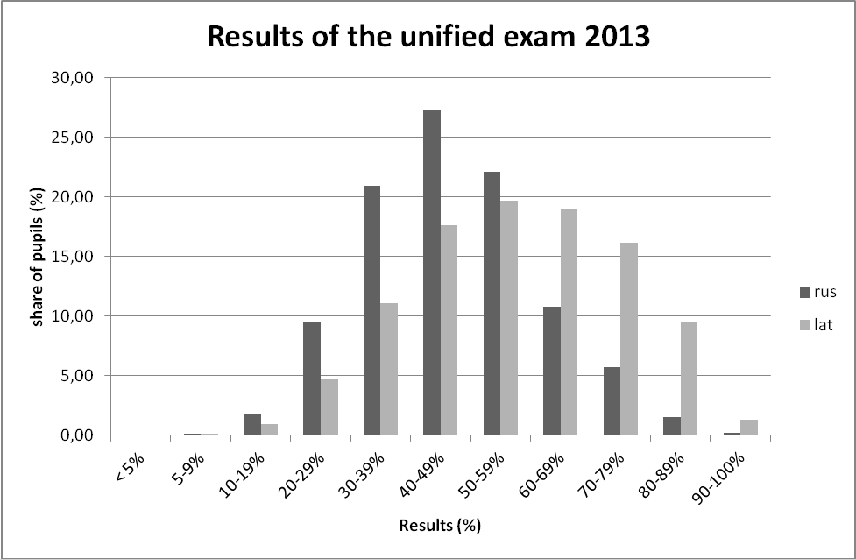

It has to be noted that the results of the exams have an impact on the possibility to receive tertiary education in publicly-funded universities and colleges. The lack of distinction between pupils learning in Latvian only and bilingually, in the present situation, may amount to discrimination.
The most pressing concern with relation to linguistic discrimination is connected with the attempts to abolish instruction in minority languages in public education, save the subjects connected with the minorities’ identity. In January, 2014, drafting legislation for this aim, scheduled to be implemented in 2018, was included in the co-operation agreement between the political parties forming the new government. An attempt to switch all public kindergartens to Latvian as the medium of instruction was rejected in the Parliament in May 2013, but only with 43 votes „against” and 2 abstentions – 41 votes, including most of the ruling parties, were cast „in favour” of moving the bill forward.
Also, the Ombudsman J. Jansons has called to introduce education in Latvian language only (save the minority language, literature and culture) for pupils after 5 or 6 years of having been educated in Latvia. The main reason included in his letter to the President in January 2014 is mistranslation of the OSCE Hague recommendations regarding the education rights of national minorities. While the recommendations on secondary school (which starts in Latvia since grade 10, not 6 or 7) read as follows: „13 (..) the number of subjects taught in the State language, should gradually be increased. Research findings suggest that the more gradual the increase, the better for the child”, the Ombudsman cites them as saying „In secondary schools, the number of subjects taught in the State language, should be increased essentially. Research findings suggest that the bigger the increase, the better for the child”. In the same time, the Ombudsman fully omits the beginning of the same para. 13., reading „13. In secondary school, a substantial part of the curriculum should be taught through the medium of the minority language”.
[13] Comments on paragraph 25 (art.17, 20, 26, 27)
The struggle against racially motivated hate speech (which is prohibited by Section 78 of the Criminal Law. In 2007, „ethnic” ground of hatred was added there to the earlier „national and racial”) is mostly conducted by the Security Police and focused on the internet – so are 17 of 18 criminal cases initiated in January-October 2013.
Concerning the racist statements against minorities made in a more notable way, the usual practice, however, is either refusal to initiate a criminal case, or acquitting them. Probably the strangest case was connected with public statements on desirability of extermination of Jews and Roma, made in 2007. After initiating a criminal case by the police, the prosecution discontinued it on freedom of expression grounds. After the case was brought to attention of the UN Special Rapporteur on racism visiting Latvia, the case was re-initiated in time for that to be reflected in the Rapporteur’s report, and the perpetrator was even convicted, only to be acquitted on appeal in 2010 by drawing a questionable line between „racial” and „ethnic” hatred. As a result, the „narrow interpretation given to incitement to hatred” was noted by the European Commission against Racism and Intolerance in 2011. The practice of the Security Police to defer to the perpetrator in determining hate motives also made the Advisory Committee on the Framework Convention for the Protection of National Minorities „concerned” in 2013.
The parliamentary Code of Ethics, adopted in 2006, includes not appealing to race, colour, ethnicity or religion of one’s opponents. However, the repeated recommendation by the European Commission against Racism and Intolerance to explicitely prohibit incitement to racial and religious hatred in the code was not implemented.
While there are equality-oriented ideas expressed in the policy documents, their significance is undermined by divisive statements in the same documents, as noted with criticism by the Advisory Committee on the Framework Convention for the Protection of National Minorities. So is the case with labeling non-citizens as immigrants who were part of the occupation in the 2011 Guidelines on National Identity, Civil Society and Integration Policy and with the introduction of the term „constituent nation” for ethnic Latvians both there and in the 2013 amendments to the Citizenship Law. Despite this criticism, the notion of „constituent nation” has soon appeared in the draft preamble for the Constitution, prepared by E. Levits, the Latvian judge of the Court of Justice of the EU and then-head of the Constitutional Law Commission under the President of Latvia.
[14] Comments on paragraph 26 (art.17, 20, 26, 27)
The implementation of the Committee Views on the communication Raihman v. Latvia is stalled. Not only no relevant legislative changes have been made – even Mr. Raihman himself was not issued personal documents with a correct form of his name and surname. He was forced to appeal to court again; the case is pending, as at February 2014.
Similarly, the parents who wish to provide their children with personal documents with a non-Latvianized personal name, continue to meet refusals – i.e., according to the courts, „Mirons” must be written instead of „Miron” (despite the death connotations of the former in Latvian), and „Marks” must be written instead of „Mark”, preferred by the parents. Similarly, Latvian-language endings were imposed by the Supreme Court to names and surname of a child in the case described in para. 1. of the present document.
After a court case won in 2012, there is some progress with the recognized possibility to record a Latinized form of one’s patronym on the third page (non-mandatory information) of one’s passport. However, the progress is limited, as the Office of Citizenship and Migration Affairs demands official documents (in a narrow sense) to confirm the form of a patronym. Therefore, the possibility is in practice only open to those born in Soviet times and having old birth certificates or identity documents with patronyms recorded. A case on contesting this practice as applied to two recently born children is pending before the Administrative District Court at the time of writing.

A. Kuzmins, member of the LHRC Ruling Board

Department of Administrative Cases of the Senate of the Supreme Court judgment of 09.07.2012 in case No. A420598410 (SKA-184/2012) (Latvian) http://www.tiesas.lv/files/AL/2012/07_2012/09_07_2012/AL_0907_AT_SKA-0184-2012.pdf
Ombudsman’s letter No. 1-5/3 of 07.01.2014 http://www.tiesibsargs.lv/files/content/vestules/Par%20papildu%20informacijas%20sniegsanu%20ANO%20cilvektiesibu%20komitejai.pdf (Latvian)
Birth rate of ethnic Latvians is 1/6 higher that that of ethnic Russians http://ritvars.wordpress.com/2013/05/20/latviesu-dzimstiba-ir-par-16-augstaka-neka-krievu/ (Latvian)
Ethnic Latvians live two years longer than ethnic Russians http://ritvars.wordpress.com/2013/05/21/latviesi-dzivo-divus-gadus-ilgak-neka-krievi/ (Latvian)
Submission by the UN High Commissioner for Refugees for the OHCHR Compilation Report – Universal Periodic Review http://www.refworld.org/country,,,,LVA,,4cd8f3992,0.html See para. IV of the chapter “Right to nationality”
Statement to the 868th meeting of the OSCE Permanent Council http://www.osce.org/hcnm/78915
Governments should act in the best interest of stateless children http://humanrightscomment.org/2013/01/15/governments-should-act-in-the-best-interest-of-stateless-children/
Report on Latvia (fourth monitoring cycle) http://www.coe.int/t/dghl/monitoring/ecri/Country-by-country/Latvia/LVA-CbC-IV-2012-003-ENG.pdf Para. 122
The 2013 edition of the Citizenship Law http://www.vvc.gov.lv/export/sites/default/docs/LRTA/Likumi/Citizenship_Law.doc The 1998-2013 edition of the law can be found in English, for comparison, at http://unpan1.un.org/intradoc/groups/public/documents/UNTC/UNPAN018407.pdf
Naturalization statistics http://www.pmlp.gov.lv/lv/sakums/statistika/naturalizacija.html (Latvian; English version at http://www.pmlp.gov.lv/en/home/statistics/naturalization.html is not up-to-date)
Ibid.
Compare the row named (in Latvian) “Latvijas nepilsonis” in the data on the number of residents by nationality on 01.01.2012 http://www.pmlp.gov.lv/lv/assets/documents/statistika/01.07.2012/ISVP_Latvija_pec_VPD.pdf and on 01.01.2013 http://www.pmlp.gov.lv/lv/assets/documents/statistika/01012013_IRD/ISVP_Latvija_pec_VPD.pdf
Compare the numbers below in the column named (in Latvian) “Latvijas nepilsonis” in the data on 01.07.2012 http://www.pmlp.gov.lv/lv/assets/documents/statistika/IRD_01_07_2012/PSAV_Aarvalstiis_Latvijas_VPD.pdf and on 01.01.2013 http://www.pmlp.gov.lv/lv/assets/documents/statistika/01012013_IRD/PSAV_Aarvalstiis_Latvijas_VPD.pdf
Resolution on the implementation of the Framework Convention for the Protection of National Minorities by Latvia ResCMN(2011)6 https://wcd.coe.int/ViewDoc.jsp?id=1768985&Site=CM&BackColorInternet=C3C3C3&BackColorIntranet=EDB021&BackColorLogged=F5D383 Para. 1(3)
Annexes 1 and 2 to the Cabinet regulations no. 733 of 07.07.2009 http://likumi.lv/doc.php?id=194735 (Latvian)
Administrative Violations Code http://likumi.lv/doc.php?id=89648 (Latvian; English translation available at http://www.vvc.gov.lv/export/sites/default/docs/LRTA/Likumi/Latvian_Administrative_Violations_Code.doc is not up-to-date) Section 201.²⁶
1157 persons were fined in 2013 for violating the State Language Law (in Russian) http://rus.delfi.lv/news/daily/latvia/za-narushenie-zakona-o-gosyazyke-v-2013-godu-nakazany-1157-lic.d?id=44045093
Draft law “Amendments to the Labour Law” http://titania.saeima.lv/LIVS11/saeimalivs11.nsf/0/6A62BC2BFCB6AF3AC225794B003AC6C5?OpenDocument (Latvian) – Paragraph 1 of the annotation
Judgment on application No. 55707/00 http://hudoc.echr.coe.int/sites/eng/pages/search.aspx?i=001-91388
Judgment in case No. 2010-20-0106 http://www.satv.tiesa.gov.lv/upload/judg_2010_20_0106.htm
Report on Latvia (fourth monitoring cycle) CRI(2012)3 http://www.coe.int/t/dghl/monitoring/ecri/Country-by-country/Latvia/LVA-CbC-IV-2012-003-ENG.pdf Para. 130
Re: Respect for the Rights of Non-Citizens in the Republic of Latvia http://www.tiesibsargs.lv/files/content/vestules/EDSO_TS_vestule_2013_dec_ENG.pdf
“On the legal status of non-citizens” 8 December 2011, No. 6-1/1007 (Latvian) http://www.tiesibsargs.lv/img/content/tiesibsarga_viedoklis_par_nepilsonu_tiesisko_statusu.pdf
Opinion in a verification procedure. September 2008 – a letter to MP J. Pliners [specific date and No. of the document not reproduced in the copy published on the website] (Latvian) http://www.tiesibsargs.lv/img/content/atzinums_par_pilsonu_un_nepilsonu_tiesibam_2008_09.pdf See paras. 3 and 4 in the summary on page 29
http://www.prisonstudies.org/country/latvia
New directions of the penal policy in force since April the 1st (Latvian). http://www.lvportals.lv/viedokli.php?id=253224
Concept for Prison Infrastructure Development (Latvian) http://polsis.mk.gov.lv/LoadAtt/file26424.doc
The new prison might be located in Liepaja and Riga instead of Olaine (in Latvian) http://www.lsm.lv/lv/raksts/latvija/zinas/jaunais-cietums-varetu-atrasties-nevis-olaine-bet-liepaja-un-pie.a68965/
Court will force Ospiov to remove the bilingual plate with the name of the street (Russian) http://www.mixnews.lv/ru/politics/news/2013-01-09/114936
State Language Centre warns the schools where Ushakov spoke Russian (Russian) http://rus.delfi.lv/news/daily/latvia/centr-gosyazyka-sdelal-zamechanie-shkole-gde-ushakov-govoril-po-russki.d?id=42779962
Kozlovskis: securty information must be available in various languages (Russian) http://rus.delfi.lv/news/daily/politics/kozlovskis-informaciya-o-bezopasnosti-dolzhna-byt-dostupna-na-raznyh-yazykah.d?id=42801830
State Language Centre forbids bilingual anti-corruption posters (Russian) http://rus.delfi.lv/news/daily/latvia/centr-gosyazyka-zapretil-dvuyazychnye-plakaty-o-borbe-s-korrupciej.d?id=43065876 The prohibited poster – http://www.diena.lv/sodien-laikraksta/knab-kampanas-plakatu-kritize-vvc-13994021
State Language Centre against English words on displays in Jurmala (Russian) http://rus.delfi.lv/news/daily/latvia/centr-gosyazyka-protiv-anglijskih-slov-na-tablo-v-yurmale.d?id=43347575
Trams of Daugavpils left without Russian language (Russian) http://rus.ruvr.ru/2013_08_02/Tramvai-Daugavpilsa-ostalis-bez-russkogo-jazika-8709/
State Language Centre forbids to dissiminate information on euro in Russian (Russian) http://www.delfi.lv/biznes/latvija-evrozone/centr-gosyazyka-zapretil-rasprostranyat-informaciyu-o-evro-po-russki.d?id=43818986
State Language Centre forbade to invite women to cancer screenings in Russian (Russian) http://www.mixnews.lv/ru/society/news/2013-10-17/135108
The Ombudsman has found no violations in the prohibition of counter-cancer letters in Russian (Russian) http://www2.mixnews.lv/ru/exclusive/news/2013-12-14/139207
Latvian Administrative Violations Code http://likumi.lv/doc.php?id=89648 (Latvian; English translation available at http://www.vvc.gov.lv/export/sites/default/docs/LRTA/Likumi/Latvian_Administrative_Violations_Code.doc is not up-to-date)
Number and essence of administrative violation cases between January 1, 2000 and December 31, 2012 (in Latvian) http://www.vvc.gov.lv/export/sites/default/files/statistika/adm_sodu_statistika_2012.pdf
Electronic Mass Media Law http://www.vvc.gov.lv/export/sites/default/docs/LRTA/Likumi/Electronic_Mass_Media_Law.doc
The National Electronic Mass Media Council does not grant the status of a national media to “Krievu Hitu Radio” (in Latvian) http://www.neplpadome.lv/lv/sakums/padome/padomes-sedes/sedes-sadalas/neplp-nepieskir-nacionala-plassazinas-lidzekla-statusu-%E2%80%9Ckrievu-hitu-radio%E2%80%9D.html
Addendum to the report to the Human Rights Council/ A/HRC/7/19/Add.3 http://daccess-dds-ny.un.org/doc/UNDOC/GEN/G08/116/23/PDF/G0811623.pdf?OpenElement Para. 88
Resolution on the comprehensive monitoring report… P5_TA(2004)0180 http://www.europarl.europa.eu/sides/getDoc.do?pubRef=-//EP//TEXT+TA+P5-TA-2004-0180+0+DOC+XML+V0//EN Para. 74
Resolution on National Minorities. July 2004. http://www.oscepa.org/publications/declarations/2004-edinburgh-declaration/232-edinburgh-declaration-english/file Para. 16
Latvia. Parliamentary elections 2 October 2010. Final Report http://www.osce.org/odihr/elections/latvia/74785 Para. A 1 of chapter XV
Statement to the 868th meeting of the OSCE Permanent Council. 2011 http://www.osce.org/hcnm/78915
Local and Regional Democracy in Latvia. Recommendation 317 (2011) https://wcd.coe.int/ViewDoc.jsp?id=1857271&Site=COE&BackColorInternet=C3C3C3&BackColorIntranet=CACC9A&BackColorLogged=EFEA9C Para 5, f)
Memorandum to the government of Latvia CommDH(2007)9 https://wcd.coe.int/ViewDoc.jsp?id=1134279&Site=CommDH&BackColorInternet=FEC65B&BackColorIntranet=FEC65B&BackColorLogged=FFC679 Para. 43
Second Opinion on Latvia ACFC/OP/II(2013)001 http://www.coe.int/t/dghl/monitoring/minorities/3_FCNMdocs/PDF_2nd_OP_Latvia_en.pdf Para. 158
Report on Latvia (fourth monitoring cycle) CRI(2012)3 http://www.coe.int/t/dghl/monitoring/ecri/Country-by-country/Latvia/LVA-CbC-IV-2012-003-ENG.pdf Para. 128
Rules of Procedure of the Saeima http://saeima.lv/en/legislation/rules-of-procedure
Law On the Status of the Deputy of the Republic City Council and Municipality Council http://www.vvc.gov.lv/export/sites/default/docs/LRTA/Likumi/On_the_Status_of_the_Deputy_of_the_Republic_City_Council_and_Municipality_Council.doc
Kravcov losing the court case on official language (Russian) http://rus.apollo.lv/novosti/kravtsov-proigral-sud-po-delu-o-gosyazyke/621015
Distribution of the population of Latvia by nationality. Date – 01.07.2013 (Latvian) http://www.pmlp.gov.lv/lv/assets/documents/statistika/IRD_01_07_2013/ISVP_Latvija_pec_VPD.pdf
Rules of Procedure of the Saeima http://saeima.lv/en/legislation/rules-of-procedure Sections 131.³-131.⁵
Report on Latvia (fourth monitoring cycle) CRI(2012)3 http://www.coe.int/t/dghl/monitoring/ecri/Country-by-country/Latvia/LVA-CbC-IV-2012-003-ENG.pdf Para. 124
About the voters' initiated draft law "Amendments to the Citizenship Law" http://cvk.lv/pub/public/30436.html
Elections of the 11th Saeima on 17 September 2011. Statistics on the elected MPs (Latvian) http://www.cvk.lv/cgi-bin/wdbcgiw/base/Saeima11.galrez11.statko
Statistics database http://www.csb.gov.lv/en/dati/statistics-database-30501.html Choose “General Statistics - Politics and Religion” and then Table PRG10
Data on 1 July 2009, a month after elections. There were 1,860,297 citizens of Latvia living in the country. http://www.pmlp.gov.lv/lv/assets/documents/statistika/2009%201pusg/2ISVP_Latvija_pec_VPD.pdf (Latvian - see the row “Latvijas pilsonis”) 1,336,016 of them were ethnic Latvians http://www.pmlp.gov.lv/lv/assets/documents/statistika/01.01.2010/3ISVN_Latvija_pec_TTB_VPD.pdf (Latvian - see the row “Latvietis” and the column “Latvijas pilsonis”). Ergo, 28.19 % of citizens belonged to ethnic minorities or had no ethnicity record.
Ombudsman’s letter No. 6-8/687 of 30.08.2012 http://www.tiesibsargs.lv/img/content/atzinumi/romi_es_lidzekli_romu_kopienai_vestule_saeimai_mk_.pdf (Latvian)
Number of general education schools and their pupils, 2002/2003, see “pa plusmam” http://izm.izm.gov.lv/upload_file/Izglitiba/Vispareja_izglitiba/Statistika/2002/skolu_sk.xls (Latvian)
Number of general education schools, 2012/2013, see “pa plusmam” (Latvian) http://izm.izm.gov.lv/upload_file/Registri_statistika/2012_2013/skolu_sk_12.xls
Report on Latvia (fourth monitoring cycle) CRI(2012)3 http://www.coe.int/t/dghl/monitoring/ecri/Country-by-country/Latvia/LVA-CbC-IV-2012-003-ENG.pdf Para. 73, footnote
Decision of the Administrative Regional Court of 05.11.2009. in case No. A7023109 (AA-43-2680-09/16), not published
Regulations No. 530 of the Cabinet of Ministers, adopted on 06.08.2013 http://likumi.lv/doc.php?id=259125 See annex 25 (Latvian)
“The idea is not to switch to Latvian language only” (in Russian) http://vesti.lv/politics/444-interview/81484-qrech-ne-idet-o-perehode-shkol-tolko-na-latyshskijq.html
Website of the National Centre for Education Curricula - http://visc.gov.lv/
Co-operation agreement (Latvian) http://www.mk.gov.lv/lv/mk/darbibu-reglamentejosie-dokumenti/straujumas-valdibas-sadarbibas-ligums/ See Para. 1 of the Annex.
Record of the vote on 30 May 2013 on bill No. 670/Lp11 “Amendments to the Education Law” (Latvian) http://titania.saeima.lv/LIVS11/SaeimaLIVS2_DK.nsf/0/1E5D578DC9A34C9DC2257B7B0078DD49?OpenDocument
The Hague recommendations regarding the education rights of national minorities http://www.osce.org/hcnm/32180?download=true
Quotation in the Ombudsman’s letter, in Latvian: “Vidusskolās mācību priekšmetiem, kas tiek pasniegti valsts valodā, ir jātiek būtiski palielinātiem. Pētījumu rezultāti norāda uz kopsakarību, jo izteiktāks ir palielinājums, jo labāk bērnam”. http://www.tiesibsargs.lv/files/content/vestules/Bilingvala_izglitiba_Vestule_Valsts_prezidentam_14012014.pdf A correct Latvian translation, reading as follows: “13 (..) Šajā periodā būtu pakāpeniski jāpalielina valsts valodā mācāmo priekšmetu skaits. Pētījumi liecina – jo pakāpeniskāks ir šis process, jo labāk bērniem” is available at the website of the Human Rights Institute of the University of Latvia http://www.humanrights.lv/doc/regional/hagrec.htm
The criminal comments on the net are most often insulting ethnic Latvians and Jews (Russian) http://rus.delfi.lv/news/daily/latvia/v-prestupnyh-kommentariyah-v-internete-chasche-vsego-oskorblyayut-latyshej-i-evreev.d?id=43720576
Addendum “Mission to Latvia” to the report to the Human Rights Council by the Special Rapporteur on racism A/HRC/7/19/Add.3 http://daccess-dds-ny.un.org/doc/UNDOC/GEN/G08/116/23/PDF/G0811623.pdf?OpenElement Para. 64
Report on Latvia (fourth monitoring cycle) CRI(2012)3 http://www.coe.int/t/dghl/monitoring/ecri/Country-by-country/Latvia/LVA-CbC-IV-2012-003-ENG.pdf Para. 16
Ibid. Para. 15-19
Second Opinion on Latvia ACFC/OP/II(2013)001 http://www.coe.int/t/dghl/monitoring/minorities/3_FCNMdocs/PDF_2nd_OP_Latvia_en.pdf Para. 62
Rules of Procedure of the Saeima http://saeima.lv/en/legislation/rules-of-procedure Para. 8 of the Annex (omission of mentioning one’s opponents and the term “nationality” in the text are mistakes of translation; ethnicity is meant. Latvian text available at http://likumi.lv/doc.php?id=57517 )
Report on Latvia (fourth monitoring cycle) CRI(2012)3 http://www.coe.int/t/dghl/monitoring/ecri/Country-by-country/Latvia/LVA-CbC-IV-2012-003-ENG.pdf Para. 84
Second Opinion on Latvia ACFC/OP/II(2013)001 http://www.coe.int/t/dghl/monitoring/minorities/3_FCNMdocs/PDF_2nd_OP_Latvia_en.pdf Para. 69, footnote. It has to be noted that more than 40 % of the non-citizens were born in Latvia, as at 2012. See Second Report on the Implementation of the Framework Convention for the Protection of National Minorities by the Republic of Latvia. Annex 1, Table No. 2. http://www.coe.int/t/dghl/monitoring/minorities/3_FCNMdocs/PDF_2nd_SR_Latvia_en.pdf
Ibid., Para. 47 and 69
E. Levits A suggestion for a detailed preamble for the Constitution, with a commentary (Latvian) http://www.juristavards.lv/doc.php?id=260080
Administrative district court judgment of 18.07.2013 in case No. A420368313 (Latvian; anonymized text) http://www.tiesas.lv/Media/Default/Admin.tiesu%20spriedumi/Admin.raj.tiesas%20spriedumi/2013/J%C5%ABlijs/18.07.2013/AL_1807_raj_A-03683-13_39.pdf Later decisions by the Administrative Regional Court (of 24.11.2013) and by the Department of Administrative Cases of the Supreme Court (of 24.01.2014), with the same conclusion, are not published
Administrative district court judgment of 19.07.2013 in case No. A420383312 (Latvian; anonymized text) http://www.tiesas.lv/Media/Default/Admin.tiesu%20spriedumi/Admin.raj.tiesas%20spriedumi/2013/J%C5%ABlijs/19.07.2013/AL_1907_raj_A-01137-13_26.pdf We lack information on possible further development of the case.
Administrative district court judgment of 26.10.2012 in case No. A420641610 (Latvian; anonymized text) http://www.tiesas.lv/files/AL/2012/10_2012/26_10_2012/AL_2610_raj_A-00377-12_26.pdf
Case No. A420356113

